*­*

|  |  |
| --- | --- |
| *Pacific Gas and Electric Company* | |
| Release 7.7.3 Installation Guide | |
|  |  |
|  |  |
| Project | ED AM/GIS |
|  |  |
| Prepared by | Ashish Narasimham/Roger Carribine |
| Date | 5/27/2014 |
| Version | 1.0 |
| Version Type | Final |

|  |  |  |  |
| --- | --- | --- | --- |
| Revision History | | | |
| Document # | Date | Author | Summary of Changes |
| 1.0 | 1/7/14 | Ashish Narasimham/Roger Carribine | Initial Document Creation |

# Introduction

## Purpose

This document is intended to detail the implementation and configuration steps required to implement Release 7.7.3 Installation Guide. This document describes the various configuration aspects required to complete any manual or automatic patch associated with this release. Each section in this document contains the steps required to patch the system in production.

## Terms Used

|  |  |
| --- | --- |
| OOTB | Out of the box. Unmodified from the commercial version. |
| TFS | Team Foundation Server |

## External Documents

1. Location of necessary files:
   1. \\sfetgis-nas01\sfgispoc_data\ApplicationDevelopment\IBM_Delivery\ReleaseInstructions\7.7.3 EDER 2.2

## List of Fixes

Below is the list of change requests detailing all fixes for the data model for this release:

|  |  |  |
| --- | --- | --- |
| **Item Number** | | **Title** |
| [11098](http://edappgistfsprd1:8080/tfs/ElectricDistCollection/EDAMGIS/_workItems#_a=edit&id=11098) | | UFM Pilot - Data Model 8.0 changes |
| [14213](http://edappgistfsprd1:8080/tfs/web/wi.aspx?pcguid=15e9a9d1-95cb-4dd0-abfe-5af14ae6201f&id=14213) | PhotoVoltaicCell configuration |
| [14631](http://edappgistfsprd1:8080/tfs/web/wi.aspx?pcguid=15e9a9d1-95cb-4dd0-abfe-5af14ae6201f&id=14631) | Assign PGE Preserve Relationship AU to EDGIS.DeactivatedElectricLineSegment feature class |
| [14650](http://edappgistfsprd1:8080/tfs/web/wi.aspx?pcguid=15e9a9d1-95cb-4dd0-abfe-5af14ae6201f&id=14650) | New Photovoltaic Cell is displaying incorrectly as shown in Screenshot 5 |
| [14655](http://edappgistfsprd1:8080/tfs/web/wi.aspx?pcguid=15e9a9d1-95cb-4dd0-abfe-5af14ae6201f&id=14655) | Create ConduitSystem_DuctBank Relationship |
| [14657](http://edappgistfsprd1:8080/tfs/web/wi.aspx?pcguid=15e9a9d1-95cb-4dd0-abfe-5af14ae6201f&id=14657) | JP Number and JPA Sequence reverted to <Null> on new pole. Joint Pole District attribute is still copying over (FYI – Pacific Bell is NOT a Joint Pole District). |
| [14658](http://edappgistfsprd1:8080/tfs/web/wi.aspx?pcguid=15e9a9d1-95cb-4dd0-abfe-5af14ae6201f&id=14658) | Getting error message while updating voltage regulator phase designation |
| [14660](http://edappgistfsprd1:8080/tfs/web/wi.aspx?pcguid=15e9a9d1-95cb-4dd0-abfe-5af14ae6201f&id=14660) | New Photovoltaic Cell is displaying incorrectly as shown in Screenshot 5 |
| [14661](http://edappgistfsprd1:8080/tfs/web/wi.aspx?pcguid=15e9a9d1-95cb-4dd0-abfe-5af14ae6201f&id=14661) | Assign AU’s |
| [14662](http://edappgistfsprd1:8080/tfs/web/wi.aspx?pcguid=15e9a9d1-95cb-4dd0-abfe-5af14ae6201f&id=14662) | Create Dimension Feature Class |
| [14663](http://edappgistfsprd1:8080/tfs/web/wi.aspx?pcguid=15e9a9d1-95cb-4dd0-abfe-5af14ae6201f&id=14663) | Insert GlobalIDs into all new feature classes |
| [14664](http://edappgistfsprd1:8080/tfs/web/wi.aspx?pcguid=15e9a9d1-95cb-4dd0-abfe-5af14ae6201f&id=14664) | Update Available Field on Duct |
| [14665](http://edappgistfsprd1:8080/tfs/web/wi.aspx?pcguid=15e9a9d1-95cb-4dd0-abfe-5af14ae6201f&id=14665) | Add Model Names to Model Name Domains |
| [14666](http://edappgistfsprd1:8080/tfs/web/wi.aspx?pcguid=15e9a9d1-95cb-4dd0-abfe-5af14ae6201f&id=14666) | Apply UFM Object Model Names |
| [14667](http://edappgistfsprd1:8080/tfs/web/wi.aspx?pcguid=15e9a9d1-95cb-4dd0-abfe-5af14ae6201f&id=14667) | Apply UFM Field Model Names |
| [14727](http://edappgistfsprd1:8080/tfs/ElectricDistCollection/EDAMGIS/_workitems/edit/14727) | Apply Permissions on UFMDataset In Pre-Prod -EDER 2.2 Release |

## Summary of Steps to Complete Patch

These are the high-level steps to complete the installation and configuration of the data model patch. Use this table as a guide for completing the installation. Links are provided that can lead either within the document for detailed explanations or to external sites such as Sharepoint.

Table of Contents

1 Introduction 3

1.1 Purpose 3

1.2 Terms Used 3

1.3 External Documents 3

1.4 List of Fixes 3

1.5 Summary of Steps to Complete Patch 5

2 Open a Database Connection in ArcCatalog 7

3 Create ConduitSystem_DuctBank Relationship 8

4 Create Dimension Feature Class 13

5 Insert GlobalIDs into all new feature classes 21

6 Update Available Field on Duct 22

7 Add Model Names to Model Name Domains 23

8 Apply UFM Object Model Names 24

9 Apply UFM Field Model Names 26

10 Assign AU’s 28

11 New Photovoltaic Cell is displaying incorrectly as shown in Screenshot 5 29

12 Getting error message while updating voltage regulator phase designation 30

13 JP Number and JPA Sequence reverted to <Null> on new pole.  Joint Pole District attribute is still copying over (FYI – Pacific Bell is NOT a Joint Pole District). 31

14 Assign PGE Preserve Relationship AU to EDGIS.DeactivatedElectricLineSegment feature class 32

15 Apply Permissions on UFMDataset In Pre-Prod -EDER 2.2 Release 33

16 Update Data Model Version Table 34

17 Known Issues 35

# Open a Database Connection in ArcCatalog

1. Open ArcCatalog.
2. Within the Catalog Tree, expand “Database Connections” and open the active connection for this process. This is the connection that is referenced in the change request associated with this document (EDGIS<DB name in the format X#Y> )

# Create ConduitSystem_DuctBank Relationship

1. At the root level, right click in the empty area in the Contents tab of the right side panel.
2. Select New->Relationship Class

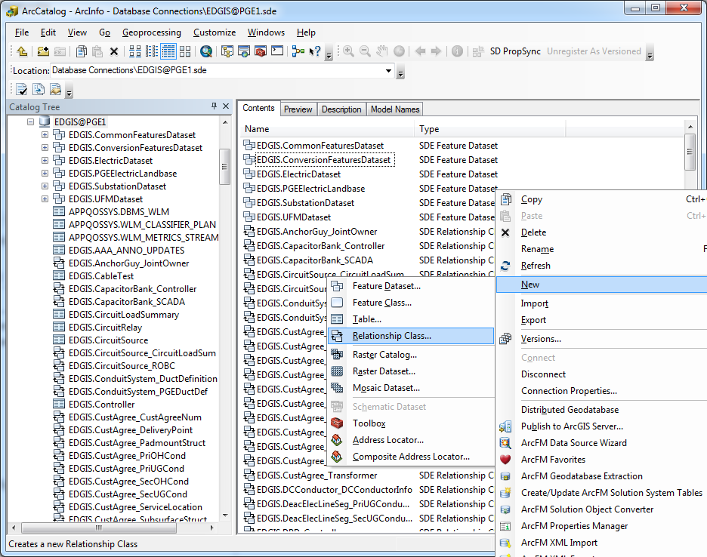

1. Set the properties of the relationship class according to the following screens:  
   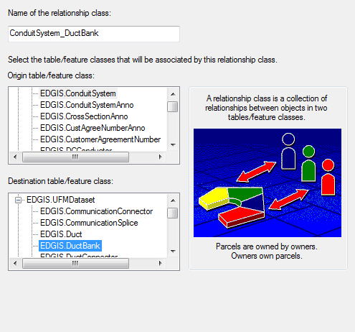

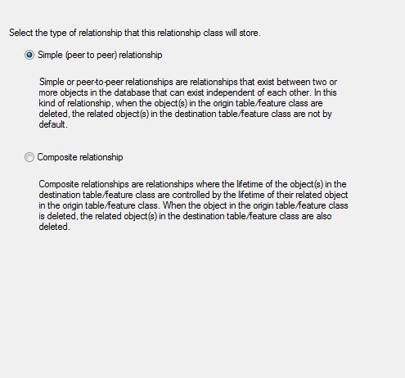

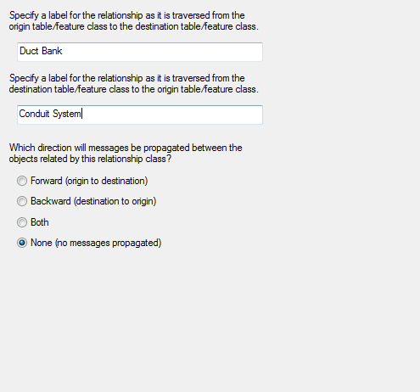

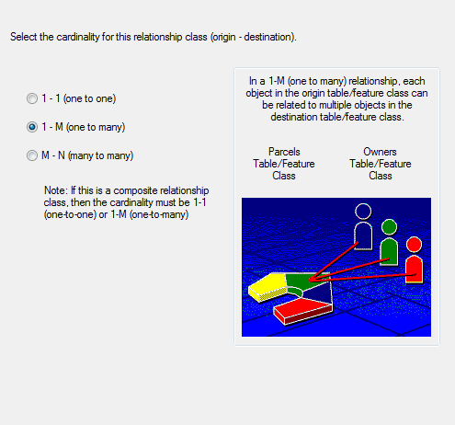

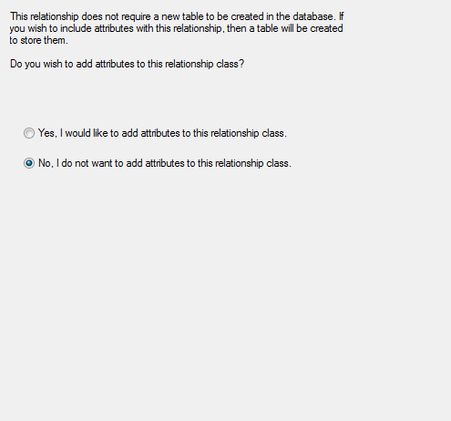

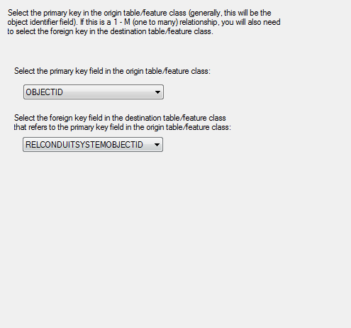

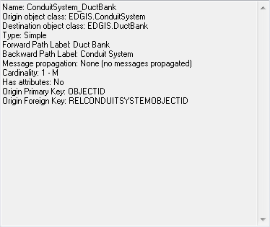

# Create Dimension Feature Class

1. In the UFMDataset, right click the empty area in the Contents tab of the right hand side panel and select New->Feature Class

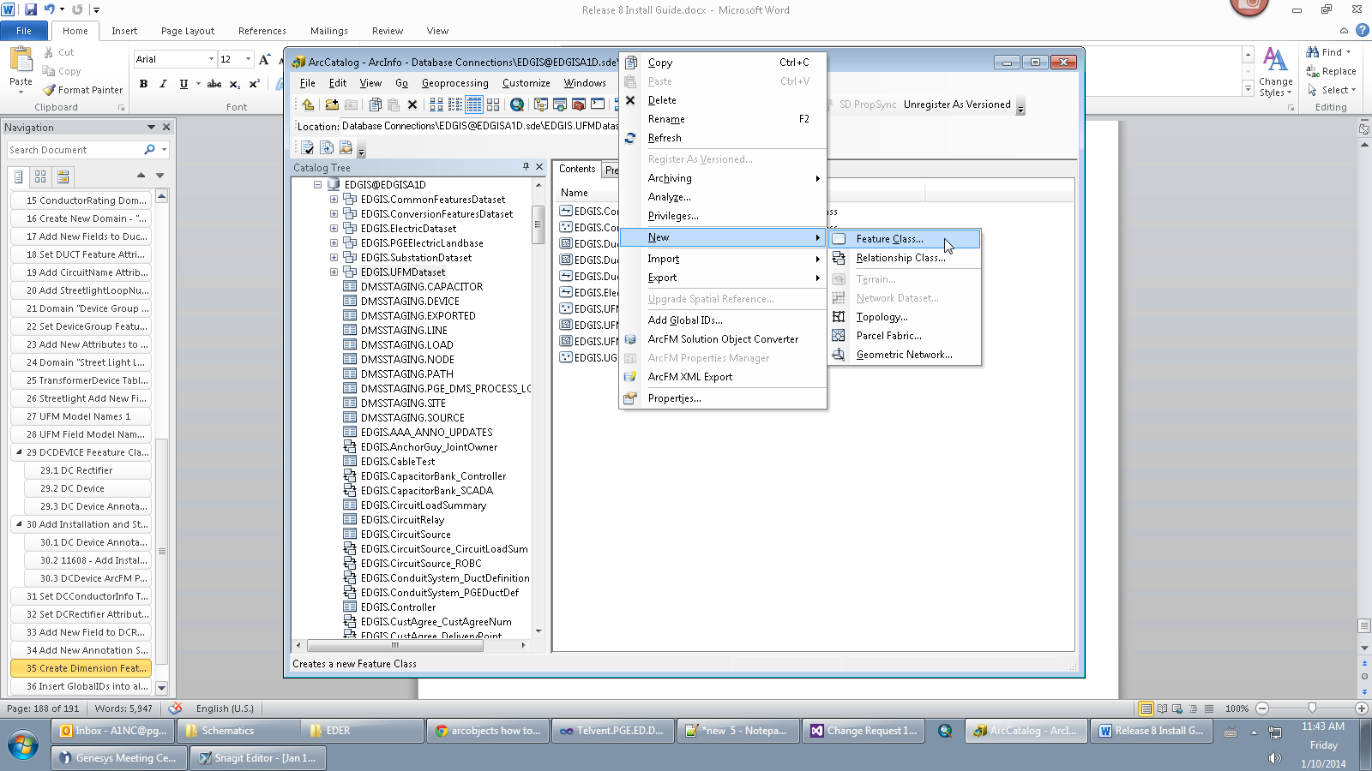

1. Enter information to match the following screen and click ”Next”.

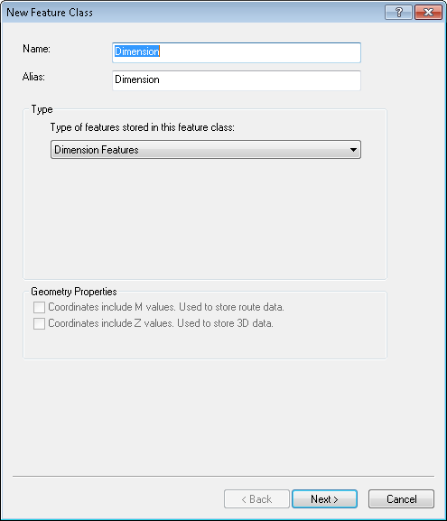

1. Enter information to match the following screen and then select “New Style”.  
   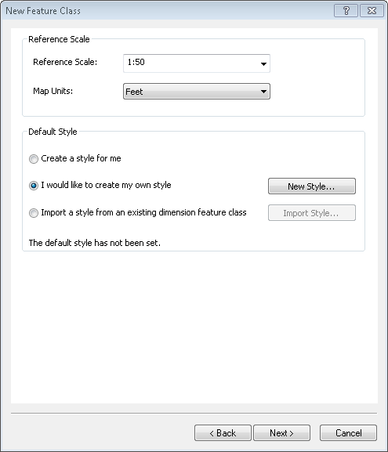
2. In the New Style dialog, fill in the information to match all three tabs of the dialog:  
   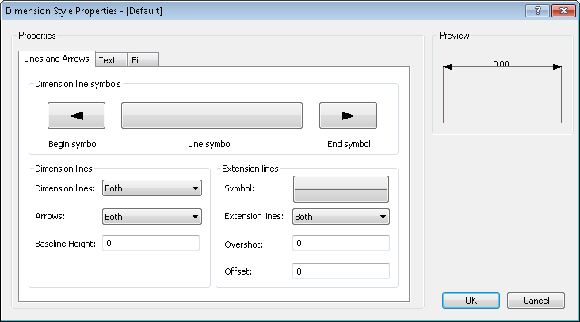  
   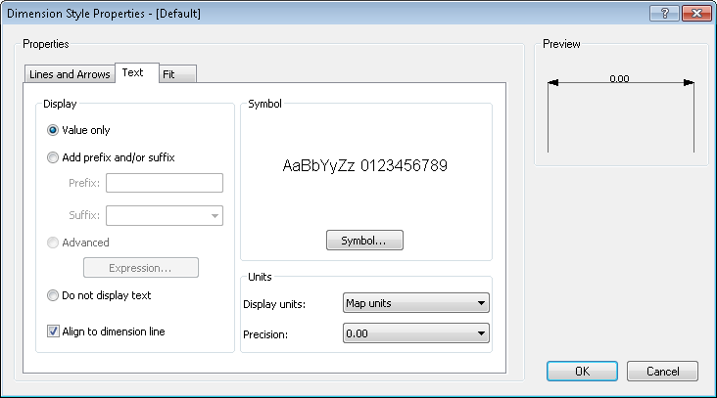  
   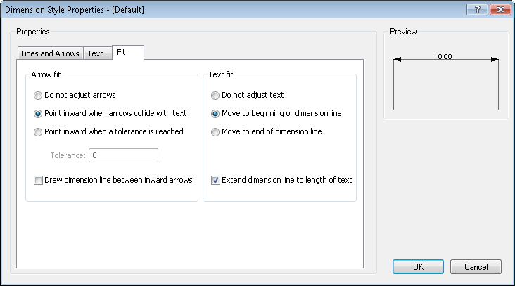
3. Press “OK“ on the above dialog to continue and select “Next”.
4. Select “Next” on the below window.  
   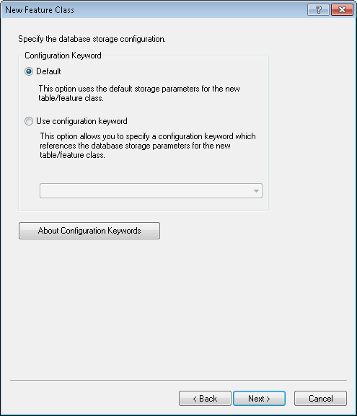
5. Enter the following list of fields into the next dialog:

|  |  |  |  |  |
| --- | --- | --- | --- | --- |
| **COLUMN_NAME** | **Alias** | **DATA_TYPE** | **NULLABLE** | **Comments** |
| GLOBALID | GLOBALID | GlobalID | No | Auto-created later on |
| OBJECTID | OBJECTID | Object ID | No | Auto-created |
| SHAPE | SHAPE | Geometry | Yes | Auto-created |
| DIMLENGTH | DIMLENGTH | Double(38,8) | No | Auto-created |
| BEGINX | BEGINX | Double(38,8) | Yes | Auto-created |
| BEGINY | BEGINY | Double(38,8) | Yes | Auto-created |
| ENDX | ENDX | Double(38,8) | Yes | Auto-created |
| ENDY | ENDY | Double(38,8) | Yes | Auto-created |
| DIMX | DIMX | Double(38,8) | Yes | Auto-created |
| DIMY | DIMY | Double(38,8) | Yes | Auto-created |
| TEXTX | TEXTX | Double(38,8) | Yes | Auto-created |
| TEXTY | TEXTY | Double(38,8) | Yes | Auto-created |
| DIMTYPE | DIMTYPE | Double(38,8) | Yes | Auto-created |
| EXTANGLE | EXTANGLE | Double(38,8) | Yes | Auto-created |
| STYLEID | STYLEID | Long Integer(10) | Yes | Auto-created |
| USECUSTOMLENGTH | USECUSTOMLENGTH | Short Integer(5) | No | Auto-created |
| CUSTOMLENGTH | CUSTOMLENGTH | Double(38,8) | No | Auto-created |
| DIMDISPLAY | DIMDISPLAY | Short Integer(5) | Yes | Auto-created |
| EXTDISPLAY | EXTDISPLAY | Short Integer(5) | Yes | Auto-created |
| MARKERDISPLAY | MARKERDISPLAY | Short Integer(5) | Yes | Auto-created |
| TEXTANGLE | TEXTANGLE | Double(38,8) | Yes | Auto-created |
| CREATIONUSER | Creation User | Text(15) | Yes |  |
| DATECREATED | Date Created | Date | Yes |  |
| DATEMODIFIED | Date Modified | Date | Yes |  |
| LASTUSER | Last User | Text(15) | Yes |  |
| CONVERSIONID | Conversion ID | Long Integer(10) | Yes |  |
| CONVERSIONWORKPACKAGE | Conversion Work Package | Text(6) | Yes | Domain: Conversion Work Package |
| LOB | LOB | Text(5) | Yes | Domain: Line of Business |
| OWNERUSERID | Owner User ID | Text(15) | Yes |  |
| EXPIREDATE | Expire Date | Date | Yes |  |
| COMMENTS | Comments | Text(255) | Yes |  |

1. Result:  
   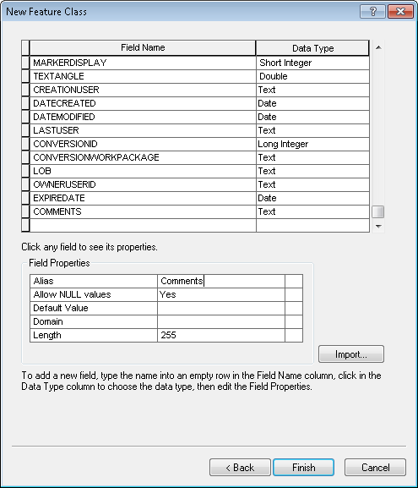
2. Select “Finish”.
3. Right-click on the UFMDataset and select Register as Versioned.

# Insert GlobalIDs into all new feature classes

1. Add GlobalID by right clicking the EDGIS.UFMDataset and clicking “Add Global IDs…”
2. Click “Yes”

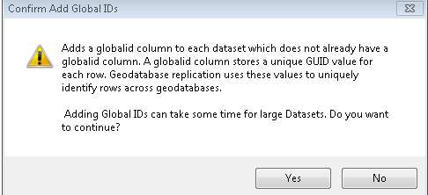

1. Observe GLOBALID has been added to the Dimension feature class.

# Update Available Field on Duct

1. Copy the ‘recreate_Duct.Available’ folder locally. Reference Section 1.3 for folder location.
2. In the ‘recreate_Duct.Available’ folder, edit the ‘00_Set_Env_Vars.bat’ file to specify the correct db/username/password/sde file. Use EDGIS as the user.
3. Open a command prompt, cd to the directory, and run ‘0_Change_Field_With_Data.bat’.
4. Copy the output to a log file named ‘duct_available_recreate.log’ and save to the release folder.

# Add Model Names to Model Name Domains

1. As EDGIS, add the following model names to the following domains:
   1. **Electric Object Class Model Name** domain
      1. UFMSPLICE
   2. **Electric Field Model Name** domain
      1. DUCTOCCUPIED

# Apply UFM Object Model Names

1. For the following list of feature classes:
2. Right click the feature class in either the ElectricDataset or UFMDataset.
3. Select ArcFM Properties Manager.
4. Select the Model Names tab.
5. Select the “Electric Object Class Model Name” entry from the Domain dropdown.
6. Double click the model name on the left hand side to assign it to the feature class. It should move to the right hand side.
7. Hit Apply to save the changes.
   1. Feature Class: EDGIS.Duct
      1. Model Name: UFMDUCT
      2. Model Name: UFMVISIBLE  
         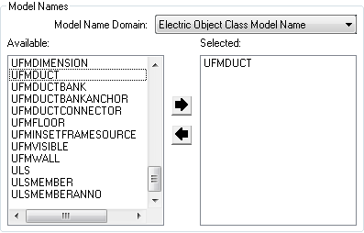
   2. Feature Class : EDGIS.SubsurfaceStructure
      1. Model Name: MANHOLEFEATURESNAP
   3. Feature Class: EDGIS.Ductbank
      1. Model Name: UFMDUCTBANK
      2. Model Name: UFMVISIBLE
   4. Feature Class: EDGIS.UFMFloor
      1. Model Name: UFMFLOOR
      2. Model Name: UFMVISIBLE
   5. Feature Class: EDGIS.UFMWall
      1. Model Name: UFMWALL
      2. Model Name: UFMVISIBLE
   6. Feature Class: EDGIS.CommunicationConnector
      1. Model Name: UFMDUCTCONNECTOR
      2. Model Name: UFMVISIBLE
   7. Feature Class: EDGIS.ElectricConnector
      1. Model Name: UFMDUCTCONNECTOR
      2. Model Name: UFMVISIBLE
   8. Feature Class: EDGIS.CommunicationSplice
      1. Model Name: UFMSPLICE
      2. Model Name: UFMVISIBLE
   9. Feature Class: EDGIS.UGElectricSplice
      1. Model Name: UFMSPLICE
      2. Model Name: UFMVISIBLE
   10. Feature Class: EDGIS.PriUGConductor
       1. Model Name: UFMVISIBLE
   11. Feature Class: EDGIS.SecUGConductor
       1. Model Name: UFMVISIBLE
   12. Feature Class: EDGIS.Dimension
       1. Model Name: UFMDIMENSION
       2. Model Name: UFMVISIBLE

# Apply UFM Field Model Names

1. For the following list of feature classes:
2. Right click the feature class in the UFMDataset.
3. Select ArcFM Properties Manager.
4. Select the Field Model Names tab.
5. Select the “Electric Field Model Name” entry from the Domain dropdown in the bottom half of the window.
6. Double click the model name on the left hand side to assign it to the field. It should move to the right hand side.
   1. Feature Class: EDGIS.Duct
      1. Field: DuctPosition
      2. Field Model Name: DUCTID

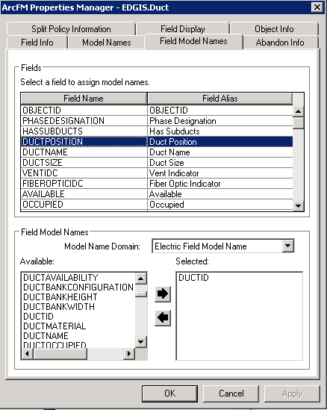

* 1. Feature Class: EDGIS.Duct
     1. Field: DuctName
     2. Field Model Name: DUCTNAME
  2. Feature Class: EDGIS.Duct
     1. Field: DuctSize
     2. Field Model Name: DUCTSIZE
  3. Feature Class: EDGIS.Duct
     1. Field: Material
     2. Field Model Name: DUCTMATERIAL
  4. Feature Class: EDGIS.Duct
     1. Field: HasSubducts
     2. Field Model Name: HASSUBDUCTS
  5. Feature Class: EDGIS.Duct
     1. Field: Available
     2. Field Model Name: DUCTAVAILABILITY
  6. Feature Class: EDGIS.Duct
     1. Field: Occupied
     2. Field Model Name: DUCTOCCUPIED
  7. Feature Class: EDGIS.Ductbank
     1. Field: FACILITYID
     2. Field Model Name: FACILITYID
  8. Feature Class: EDGIS.UFMFloor
     1. Field: FACILITYID
     2. Field Model Name: FACILITYID
  9. Feature Class: EDGIS.UFMWall
     1. Field: FACILITYID
     2. Field Model Name: FACILITYID
  10. Feature Class: EDGIS.SubsurfaceStructure
      1. Field: STRUCTURENUMBER
      2. Field Model Name: FACILITYID

# Assign AU’s

1. Assign the following object level model names, autoupdaters, and properties on the following object classes:
   1. ConduitSystem
      1. AU – On Feature Update: ArcFM UFM Conduit Cross Section AU
   2. Duct
      1. AU – On Feature Create: ArcFM UFM Duct to Conduit Synch AU
      2. AU – On Feature Update: ArcFM UFM Duct to Conduit Synch AU
      3. AU – On Feature Update: ArcFM UFM Resize Duct AU
      4. AU – On Feature Delete: ArcFM UFM Duct to Conduit Synch AU
      5. AU – On Feature Delete: ArcFM UFM Delete Duct Connector
   3. SubsurfaceStructure
      1. AU – On Feature Update: ArcFM Populate Facility ID
   4. Conduit_Conductor relationship (EDGIS.ConduitSystem_PriUG and EDGIS.ConduitSystem_SecUG)
      1. AU – On Relationship Created: ArcFM Conduit to Conductor Composite
      2. AU – On Relationship Updated: ArcFM Conduit to Conductor Composite
      3. AU – On Relationship Deleted: ArcFM Conduit to Conductor Composite
   5. ConduitSystem_DuctBank relationship
      1. AU – On Relationship Created: ArcFM UFM Populate Conduit Blob on Duct Bank Relationship Creation AU
   6. PriUGElectricLineSegment_Duct
      1. AU – On Relationship Created: ArcFM UFM Duct to Conductor Relationship AU
      2. AU – On Relationship Updated: ArcFM UFM Duct to Conductor Relationship AU
      3. AU – On Relationship Deleted: ArcFM UFM Duct to Conductor Relationship AU
   7. SecUGElectricLineSegment_Duct
      1. AU – On Relationship Created: ArcFM UFM Duct to Conductor Relationship AU
      2. AU – On Relationship Updated: ArcFM UFM Duct to Conductor Relationship AU
      3. AU – On Relationship Deleted: ArcFM UFM Duct to Conductor Relationship AU

# New Photovoltaic Cell is displaying incorrectly as shown in Screenshot 5

1. Install the new font file onto the Citrix and batch servers for the environment. Refer to Section 1.3 for font file location.

# Getting error message while updating voltage regulator phase designation

1. At the root level, right click the Voltage Regulator Unit and select ArcFM Properties Manager.
2. Select the Object Info tab.
3. Click the dropdown next to On Feature Update and select <Multiple>…
4. Double click ‘ArcFM Synch Unit Phase Designation AU’ on the right hand side box to unassign the AU from the table.

# JP Number and JPA Sequence reverted to <Null> on new pole.  Joint Pole District attribute is still copying over (FYI – Pacific Bell is NOT a Joint Pole District).

1. In the ElectricDataset, right click the SupportStructure feature class and select ArcFM Properties Manager.
2. Select the Field Model Names tab and scroll down to the Joint Pole District field. Select it.
3. Double click PGE_ASSETCOPY on the right hand side box in the bottom right corner of the screen to unassign the field model name from the field.

# Assign PGE Preserve Relationship AU to EDGIS.DeactivatedElectricLineSegment feature class

1.   Open ArcCatalog.

2.   Expand EDGIS.ElectricDataset.

3.   Right click on EDGIS.DeactivatedElectricLineSegment and select ArcFM Properties manager.

4.   Go to Object Info tab.

5.   Select PGE Preserve Relationship AU at "On Feature Create".

6. Click Apply. Click OK.

# Apply Permissions on UFMDataset In Pre-Prod -EDER 2.2 Release

Please log into EDGIS1Q as EDGIS.

1. Right click the UFMDataset and select Privileges
2. Type in a role (from the below list), type 'grant' for the corresponding permissions, and click OK.
3. Repeat steps 1 and 2 for all roles.

SDE_EDITOR - View/edit

SDE_VIEWER - View

DAT_EDITOR - View

DATACONV - View

GIS_INTERFACE - View

GISINTERFACE - View

# Update Data Model Version Table

**Database Configuration:**

1. Open SQL Plus.
2. Log in using the same server and user as was used in section 2.  
     
   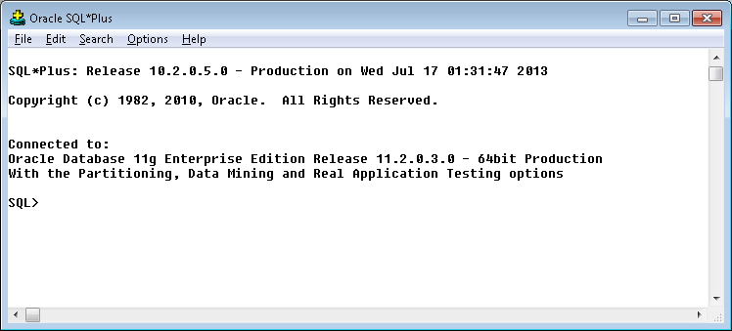
3. Run the SQL below:

update pgedatamodelversion set currentidc='N' where currentidc='Y';

insert into pgedatamodelversion (OBJECTID, CURRENTIDC, DATEAPPLIED, APPLIEDBYPERSONNAME, MODELVERSION) values (**58**,'Y',sysdate,'**<INSERT USER DONE BY>**','**7.7.3** GOLD CR14400');

commit;

# Known Issues

<Please List any other issues encountered here while following the document>